Lesson plan
Unit 12 | Lesson: 35 | My hobbies
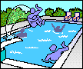
Date : ‏‏
Class: 6th form ‏
Date :
Class: 6th form ‏
Objectives:
By the end of this lesson pupils should be able to:
- Talking about likes and dislikes.
New language:
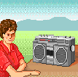
Vocabulary : reading – painting - cartoon
Structures: What’s you like ….?
Yes I do / No I don’t
Pronunciation: Vowels in minimal pairs
Teaching aids :
A tape recorder / pictures

Stage | Procedures | Time
Warming – up | Teacher asks different pupils to say the last song  Teacher asks pupils to take their slates and invites them to write a sentence after looking at the pictures :  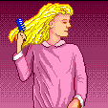  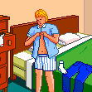 | 10mn

Presentation | Teacher presents pictures then she asks:  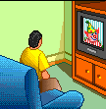  What are they doing ?  Pupils try then teacher introduces :  She listen to music . She likes music.  She reads a story . He likes stories  Harry likes cartoons.  They like computer.  Pupils use new words in sentences  Teacher asks pupils about their hobbies and makes them making a sentence using the new words. | 25mn
Practice | 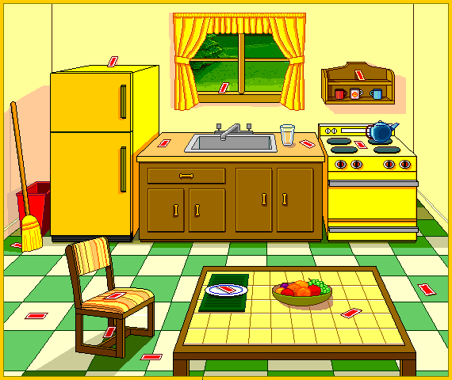  Teacher invites pupils to open their books at page174  Teacher reads.  Pupils follow on their books.  Teacher invites pupils to answer the question: Do you like cartoons ?  Pupils try .  Teacher reads the dialogue.  Pupils follow on their books.  Then pair practice.  Teacher asks pupils to read then do the activities on page 175/176/177  Then check and correct | 25mn

